**======**

**Work Object & its Predefined Properties**

* **pxCreateOperator: Operator ID / User ID  ( Admin@orgName)- Label( Admin)**
* **pxCreateOpName: Name of the operator  ( Default Name will be Admin- Sai D)**
* **pxUpdateOperator: Who has last Updated & who is the current Operator**
* **pxCreateDateTime: At what date time rule is Created**
* **pxUpdateDateTime: When it is last updated**
* **pyStatusWork: Current Status of the Work Object/ Case Status/Field Value will be assigned to this property**
* **pyID: it Holds WO ID Value**
* **pyWorkPage: Default User Page referring to Work Class/WO data will be there under pyWorkPage**

**Req: Create a Report to Fetch all the Work Objects which are waiting at Pending-VehInfo Status for last 7 days (Without Using Parameters)**

**Add Report Definition under Work Class group:**

**Under Work Layer Create Report Definition:**

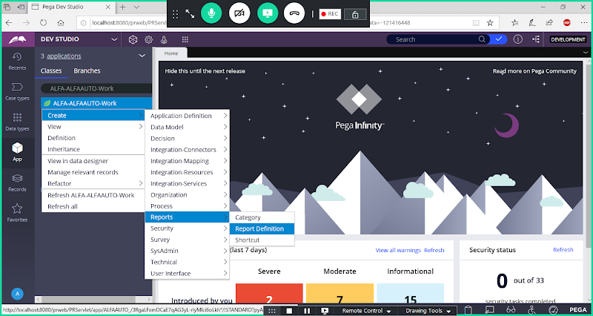

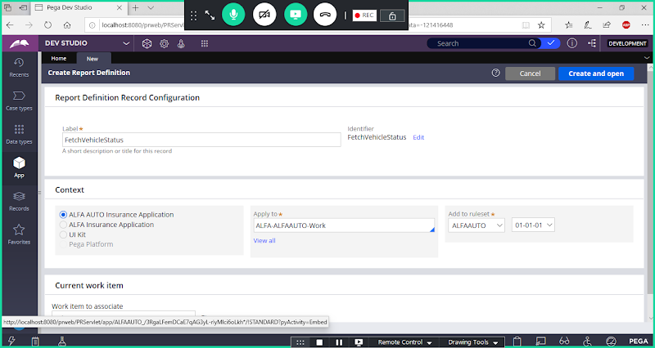

**Open**

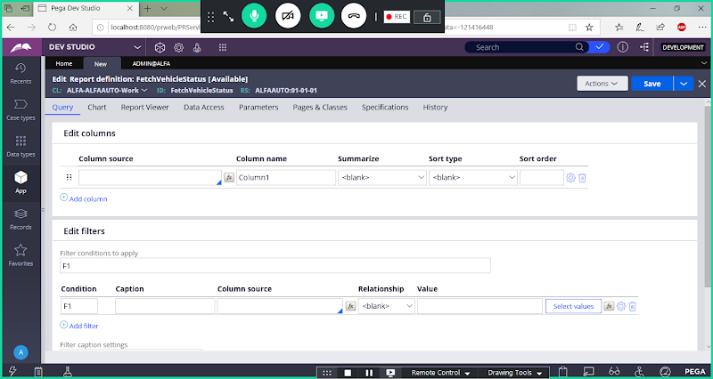

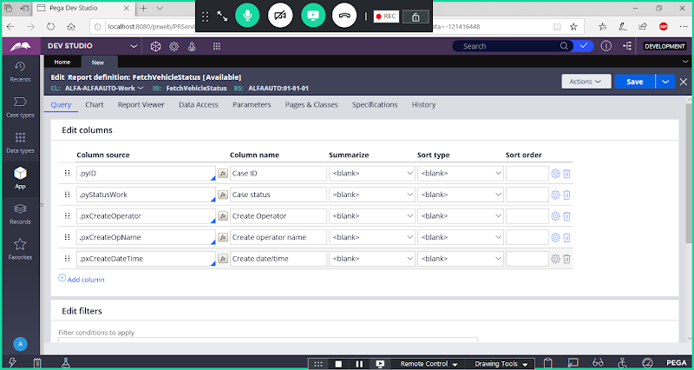

**Scroll Down to add Where Conditions**

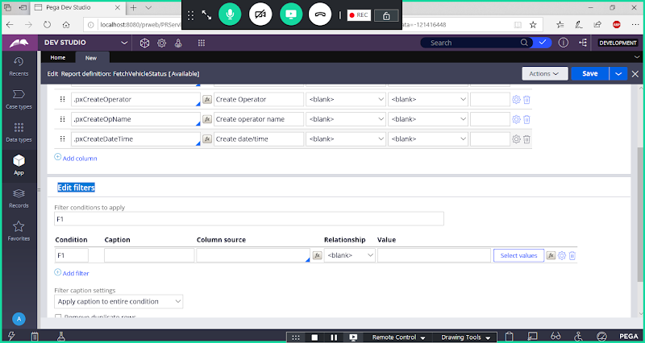

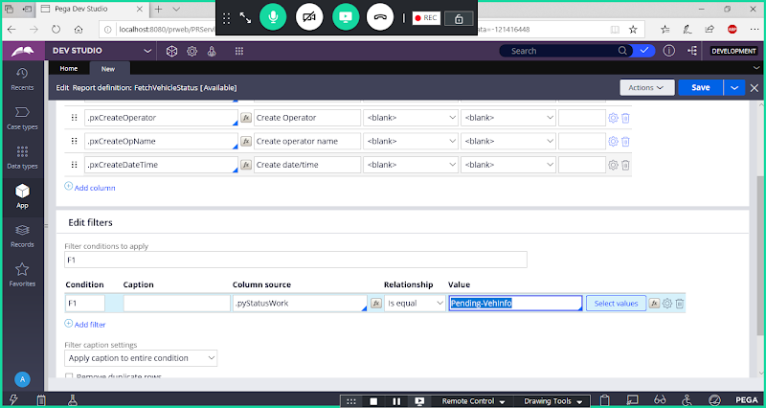

**Now Add Time Period:**

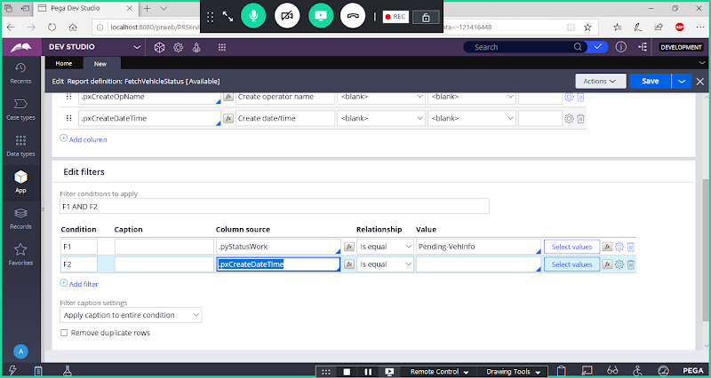

**Click on Select Values to add time period**

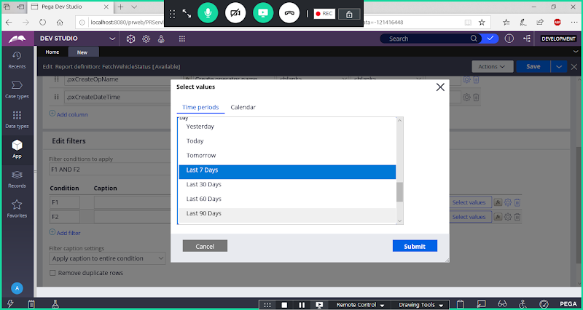

**Submit**

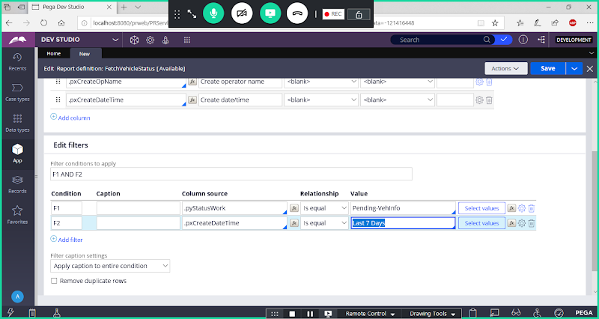

**Save Report & Run the Report**

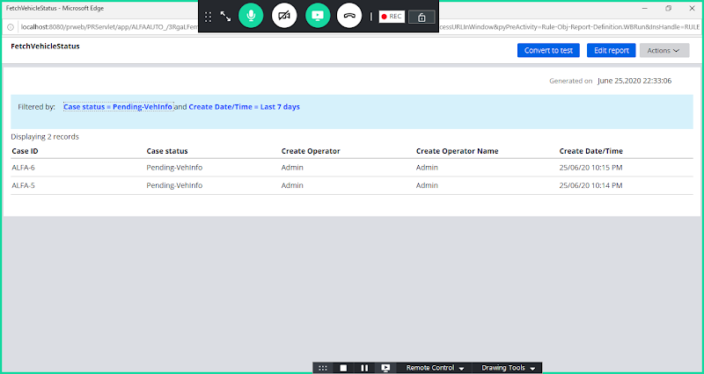

**====**

**How to Make Report Rules access from Manager Portal through Reports Browser:**

**Open Manager Portal from Launch Web Interface:**

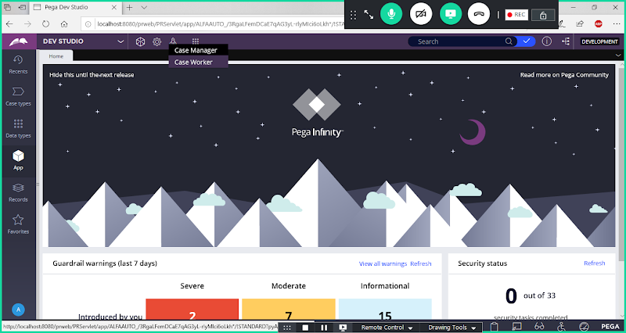

**Click on Case Manager**

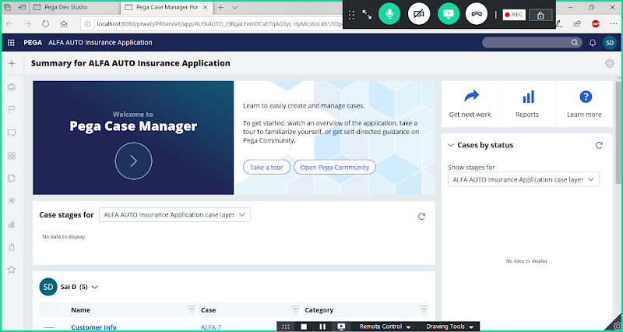

**Place your pointer on Add:**

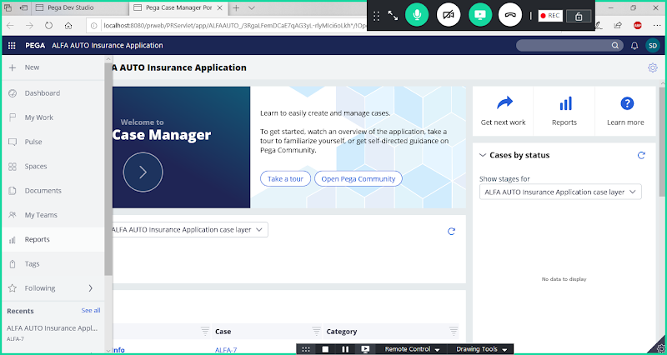

**Click on Reports Menu:**

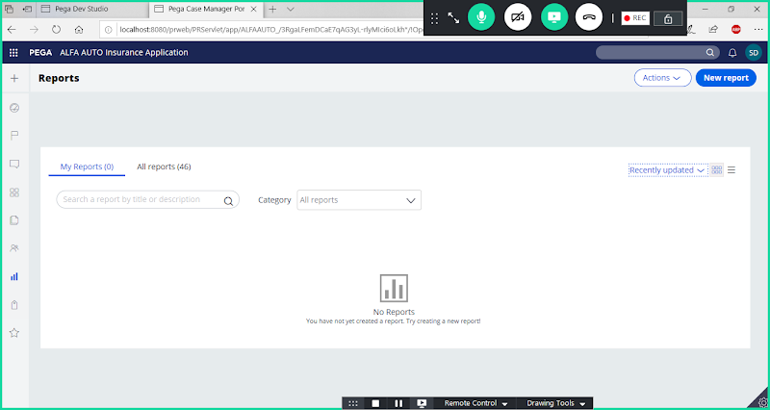

**Here by default we cannot access our user defined reports from our application.**

**Go to Developer Portal & Open Report Definition:**

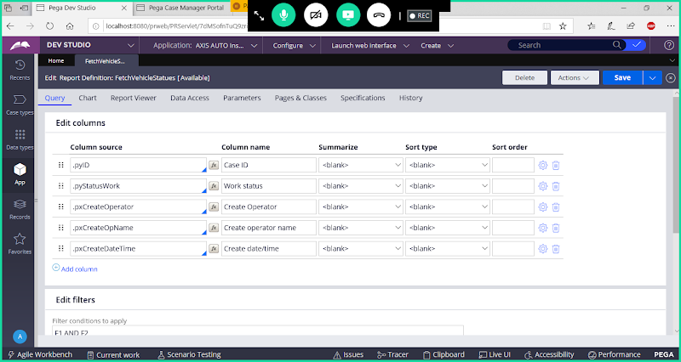

**Go to  Report Viewer tab:**

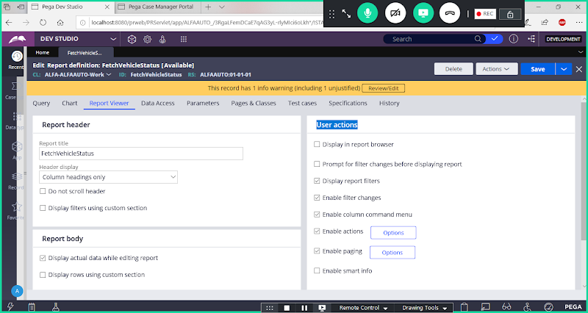

**Under User actions select-> Display in Report Browser Check box**

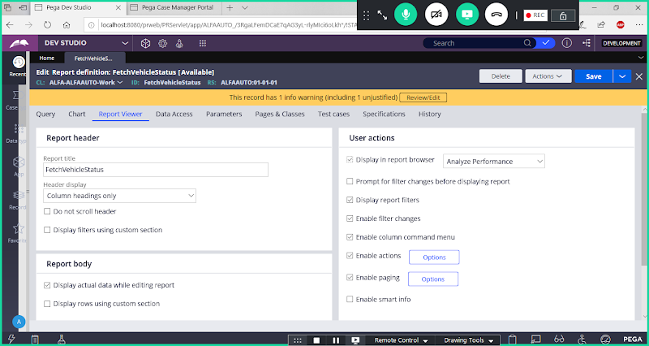

**Now Select Open Cases in the drop down**

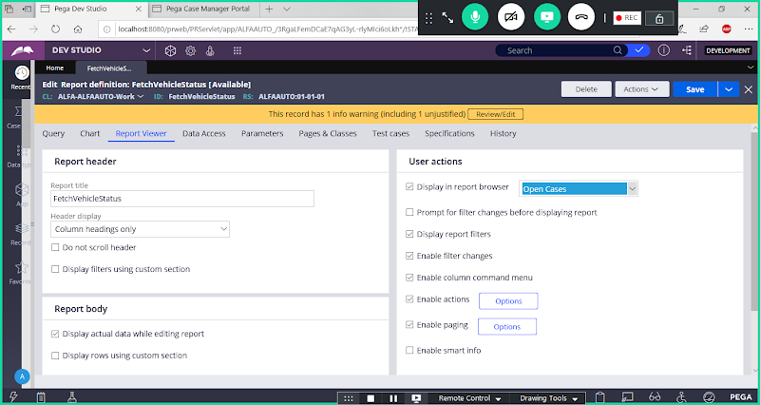

**Save Report**

**Now Open Manager Portal & Check in Reports Browser-> Open Cases we can find our report**

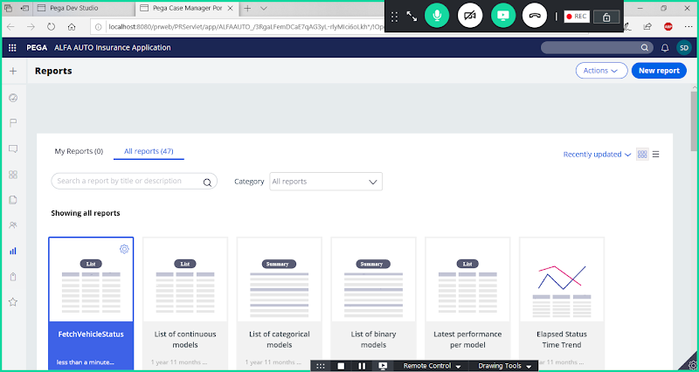

**Click on FetchVehicleStatus**

